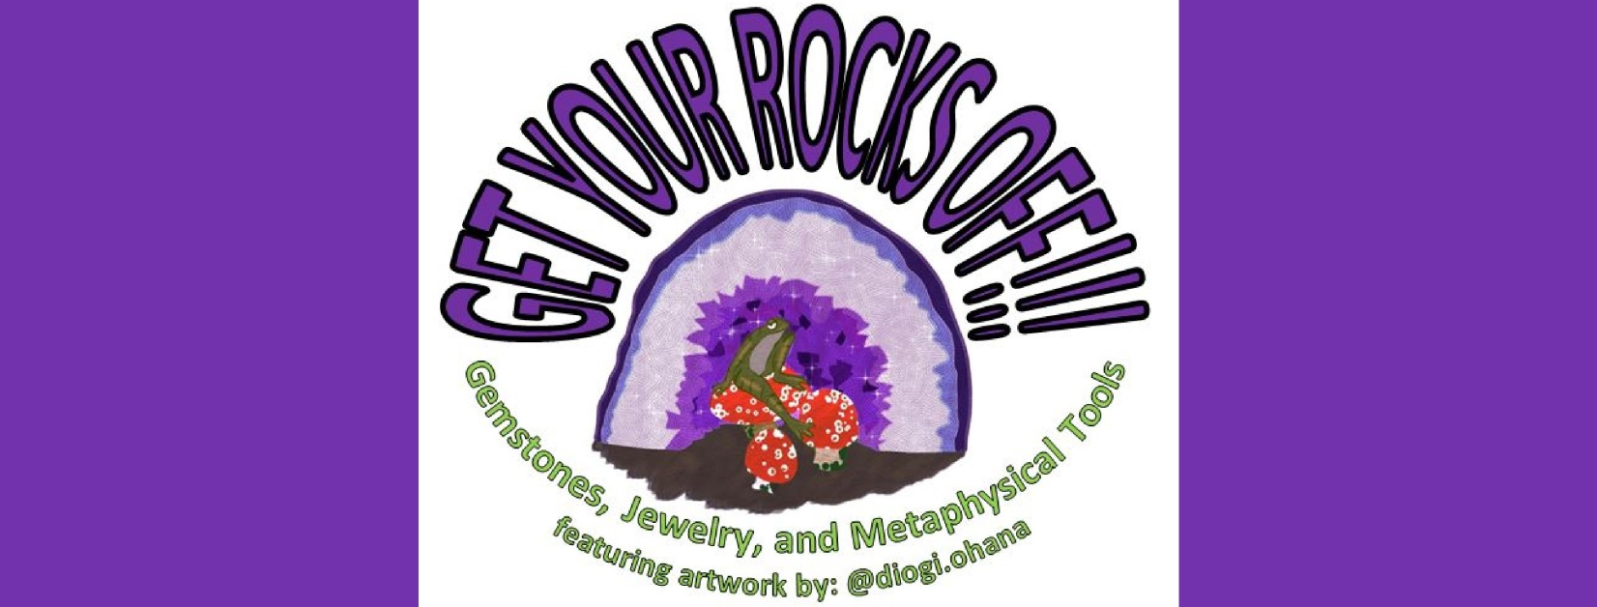

A. Beth Jones
(Owner/Operator/Artist)

Webpage: www.getyourrocksoff.shop
Email: abtjones@getyourrocksoff.shop
Like Us of Facebook: @getyourrocksoffshop



